DISHES AND THEIR ALLERGEN CONTENT – Bon Appetit Sheet 1

DISHES | 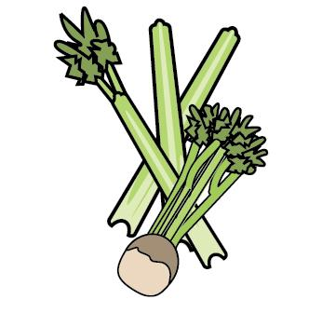 |  |  | 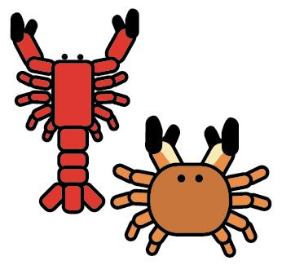 | 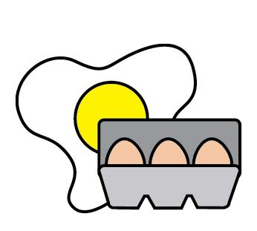 |  |  |  | 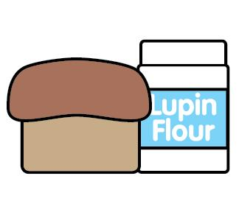 |  |  | 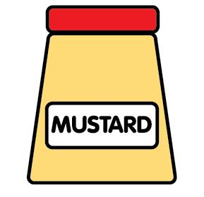 | 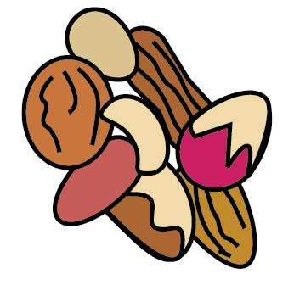 | 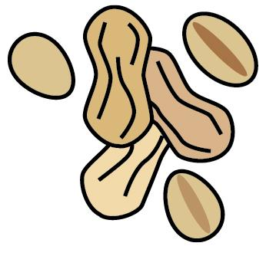 |  | 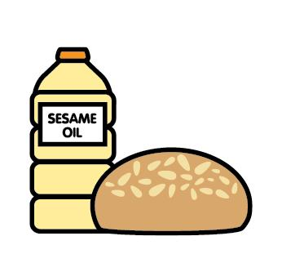 |  |  | 
Breakfast 2024 | Celery |  | Cereals containing gluten | Crustaceans | Eggs |  | Fish |  | Lupin | Milk | Mollusc | Mustard | Nuts | Peanuts |  | Sesame seeds | Soya |  | Sulphur Dioxide
Sausage roll |  |  | ✔wheat |  | May contain |  |  |  |  | ✔ |  | May contain |  |  |  | May contain | ✔ |  | ✔
Bacon roll |  |  | ✔wheat |  | May contain |  |  |  |  | ✔ |  | May contain |  |  |  | May contain | ✔
Egg roll |  |  | ✔wheat |  | ✔ |  |  |  |  | ✔ |  | May contain |  |  |  | May contain | ✔
Egg and bacon roll |  |  | ✔wheat |  | ✔ |  |  |  |  | ✔ |  | May contain |  |  |  | May contain | ✔
Egg, bacon and sausage roll |  |  | ✔wheat |  | ✔ |  |  |  |  | ✔ |  | May contain |  |  |  | May contain | ✔ |  | ✔
croissants |  |  | ✔wheat |  | ✔ |  |  |  |  | ✔ |  |  | m/c almonds hazelnut walnut |  |  | May contain | May contain
Pain au chocolate |  |  | ✔wheat |  | ✔ |  |  |  |  | ✔ |  |  | m/c almonds hazelnut |  |  | May contain | ✔
Pain au raisin |  |  | ✔wheat |  | ✔ |  |  |  |  | ✔ |  |  | m/c almonds hazelnut |  |  | May contain | ✔
Chocolate muffin |  |  | ✔wheat |  | ✔ |  |  |  |  | ✔ |  |  |  |  |  |  | ✔
Blueberry muffin |  |  | ✔wheat |  | ✔ |  |  |  |  | ✔ |  |  | m/c tree nuts | May contain |  | May contain | May contain |  | May contain
Lemon meringue muffin |  |  | ✔wheat |  | ✔ |  |  |  |  | ✔ |  |  |  |  |  |  |  |  | ✔
Review date: 30/04/26 |  |  |  |  |  | Reviewed by: |  | D Woolerton |  |  |  |  |  |  |  |  |  | You can find this template, including more information at www.food.gov.uk/allergy

